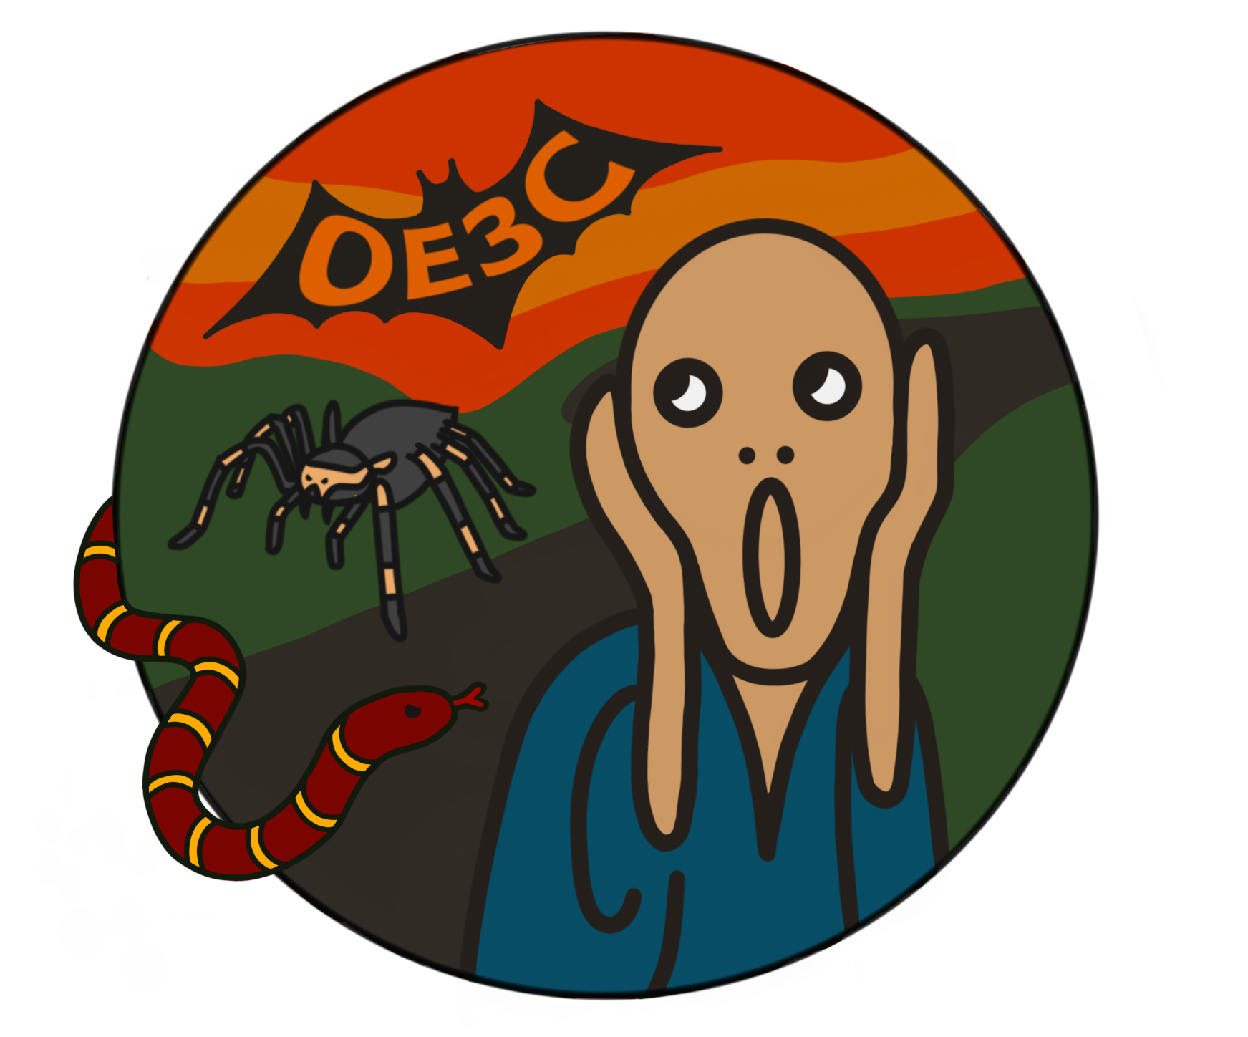

**OE3C 2024**

**Morning:** Ethology  
**Afternoon:** Physiological Ecology



**OE3C 2024**

**Morning:** Habitat Selection  
**Afternoon:** Micro & Molecular Biology



**OE3C 2024**

**Morning:** Environmental Change  
**Afternoon 1:** Plant Biology  
**Afternoon 2:** Community Ecology



**OE3C 2024**

**Morning:** Signals & Models  
**Afternoon 1:** Reproduction 1  
**Afternoon 2:** Reproduction 2



**OE3C 2024**

**Morning:** Symbiosis